Kirill Baurin
ISU-US-23-2B – Creative Exam
Date of Submission: 16.12.2025
“Design and Implementation of a Web-Based Banking System for Credit Card Management Using PostgreSQL and MongoDB”

1.1 ObjectiveThe objective of this study is to design and implement a simple web-based banking system that manages credit cards and card holders. The system should:
- Store card user information (name, surname, IIN).
- Store card information (PAN, CVV, expiry date, currency, balance).
- Support CRUD operations for users and cards.
- Support basic money operations (deposit, withdraw, transfer) with balance validation.
- Work with two different database technologies (PostgreSQL and MongoDB) and allow switching between them without changing the business logic.
- Provide a simple web interface built with Node.js, jQuery, HTML and CSS.
- Demonstrate clean separation of concerns (data access, business logic, API, UI) and portability between databases.

1.2 Requirement AnalysisFunctional requirements:
- The system shall allow creating, reading, updating and deleting card users.
- The system shall allow creating, reading, updating and deleting cards.
- The system shall allow deposits, withdrawals and transfers between cards with balance validation.
- The system shall automatically use the card holder’s name and surname when creating a card based on an existing IIN (lookup user by IIN and copy name/surname to the card).
- The system shall support switching between PostgreSQL and MongoDB as the active database at runtime.
- The system shall expose a REST API consumed by the web client.
- The system shall support partial updates for cards (only provided fields change).
Non-functional requirements
- The system should be simple to deploy on a local machine (setup script, minimal dependencies).
- The system should use clear separation of concerns: data access, business logic, web API and UI.
- The UI should be minimalistic, responsive enough for desktop, and easy to understand.
- The system should be extensible so that new databases or features can be added with minimal changes to business logic.
- The system should provide sensible validation and error messages on API responses.
- The system should keep a consistent data model across both databases.
Technology requirements
- Backend (Java) to demonstrate the repository pattern with PostgreSQL and MongoDB (interfaces CardDao and CardUserDao, plus concrete Postgres and Mongo implementations).
- Backend (Node.js + Express) for REST API and serving the web interface; runtime database switching flag (dbType).
- Databases: PostgreSQL and MongoDB (or MongoDB Atlas); same logical schema/collections.
- Frontend: HTML5, CSS, jQuery; single-page UI using AJAX to the REST API.
- Tooling: Gradle for Java build; npm for Node server; Mongo/pg drivers for database access.

1.3 Design and Implementation Notes:
- The project uses the Repository Pattern in the Java part to decouple business logic from database technology. Interfaces CardDao and CardUserDao define operations; PostgreSQL and MongoDB implementations provide concrete persistence logic. Switching implementations does not change business logic.
- The Node.js server exposes REST endpoints for card users, cards and money operations. It can work with PostgreSQL or MongoDB depending on a runtime dbType flag exposed via /api/switch-db and /api/db-type.
- The frontend is a single HTML page that communicates with the server using jQuery AJAX calls. It never accesses the databases directly; all operations go through the REST API.
- When creating a card, the user provides PAN, CVV, IIN, currency and balance. The server looks up the card holder by IIN, copies the stored name and surname into the new card record, and rejects the request if the IIN is not found. This keeps card user data consistent across card_users and cards.
- For updates, the API supports partial updates for cards: only the fields sent in the request are changed. This reduces accidental overwrites and makes the UI simpler.
- Database switching is handled server-side; the same endpoints are reused, keeping the UI unchanged while switching between PostgreSQL and MongoDB.

1.4 UML Diagrams:
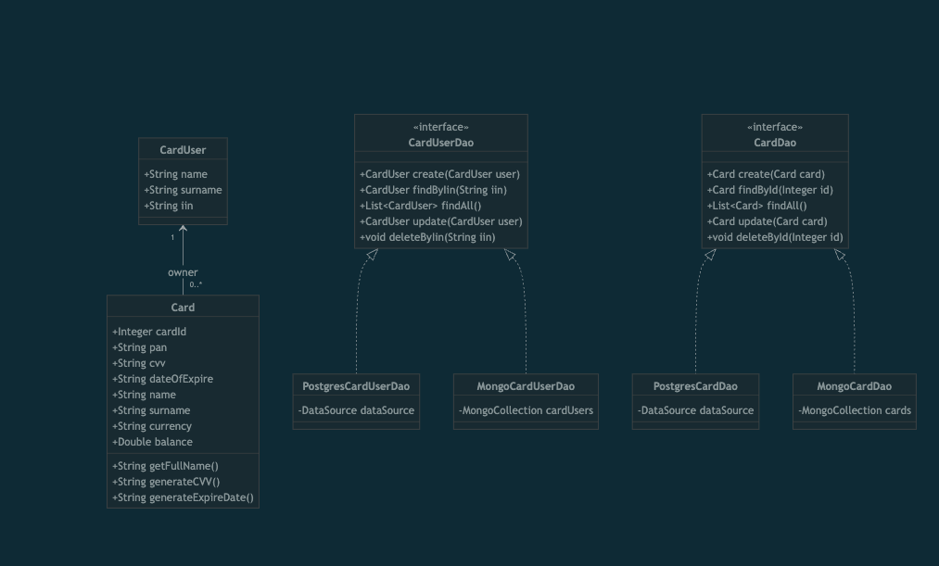
Class diagram
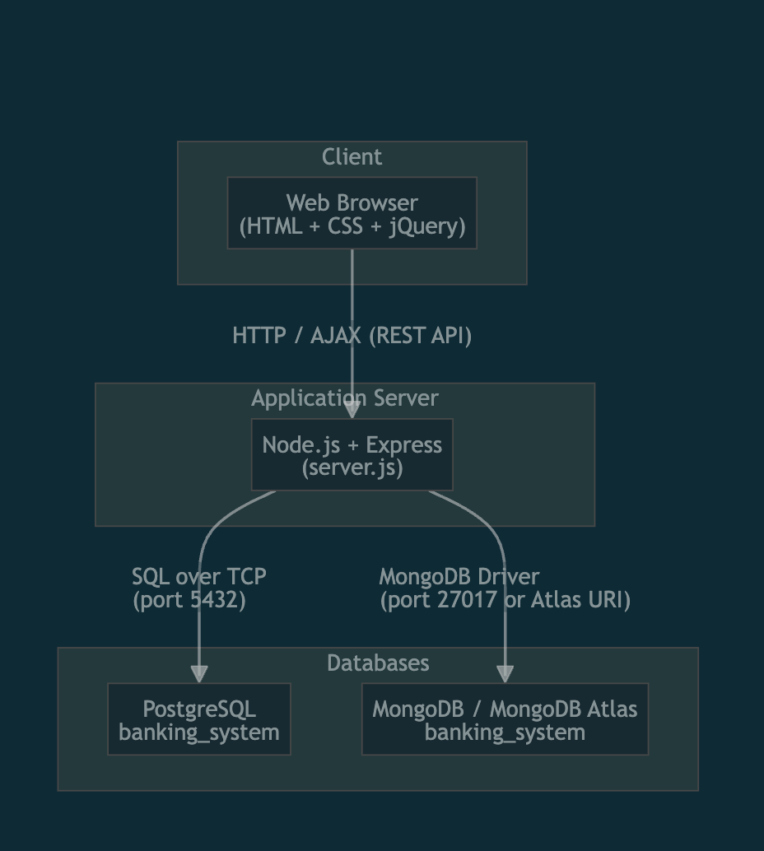
Deployment Digram

1.5 Conclusion:
This study demonstrates how to build a small banking-style system that supports two database technologies while keeping the core logic unchanged. By applying the Repository Pattern in Java and a RESTful architecture in Node.js, the system remains modular, testable and easy to extend. The web interface lets non-technical users manage card holders and cards and perform simple financial operations through a minimal UI. Future improvements could include user authentication and roles, stronger validation and constraints, transaction history logging/audit trails, and deployment to a cloud environment with CI/CD, monitoring and backups.

